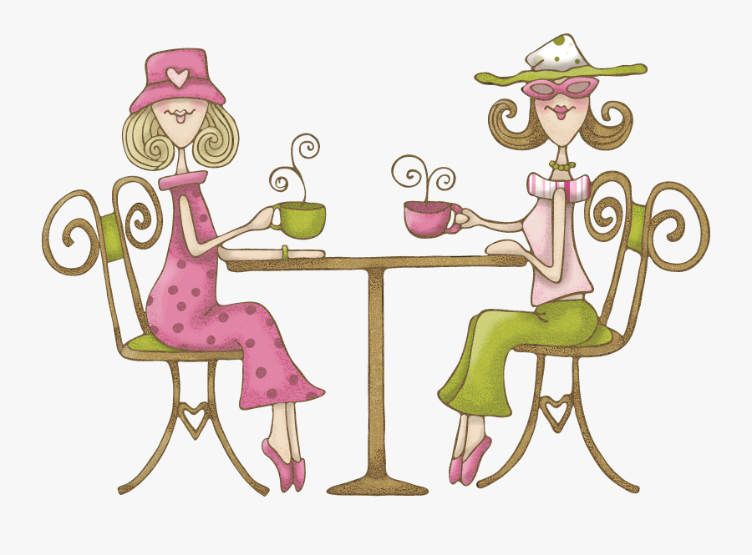

**How about getting out on a Monday afternoon?**

Come for a cup of tea or coffee and a cake

or biscuit and meet others for a chat.

Young, older, in between, all welcome.

Stay for 2 hours or grab a drink and go

it’s up to you.

**All proceeds from sales will go to the Village Shop to help keep it open**

Cup of tea or coffee and a cake or biscuit £1.00

2nd and 4th Monday of the month

**At Chart Sutton**

**Village Hall**

**from 2.00pm to 4.00pm**

June 9th & 23rd

July 14th & 28th

August 11th



AFTERNOON TEA/COFFEE, CAKE AND A CHAT